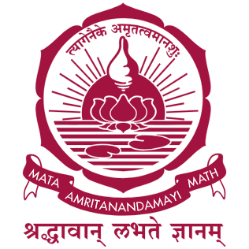

23AID113 - Elements of Computing 2
Project Title:
HackTwin: An AI-Driven Digital Twin Platform for Intelligent Hardware Design and Optimization
Team-14
Charan Boyilla – CB.AI.U4AAR25011
Poornashri – CB.AI.U4aar25053
Thulasiram Sudheeswar Reddy – CB.AI.U4AAR25053
Thippireddy Harshitha – CB.AI.U4AAR25054

Abstract
Building digital hardware usually involves designing, testing, finding problems, changing the design, and testing again. This process can take a lot of time and effort. Traditional hardware simulators only tell us whether a design works correctly, but they do not explain why a problem happened or suggest ways to improve the design.
This project proposes HackTwin, a software platform that creates a Digital Twin of a Hack hardware design. Instead of simply checking whether the hardware works, the Digital Twin studies how the hardware behaves, identifies bottlenecks, compares different hardware designs, predicts future performance, and suggests improvements before the hardware is built. Since the project is based entirely on simulation, it does not require an FPGA board, making it affordable and suitable for research as well as education.

Problem Statement
Hardware development usually follows a repetitive process:
- Design the hardware
- Simulate it
- Find errors
- Modify the design
- Simulate again
This cycle continues until the design performs well.
Current hardware simulators can tell us whether the hardware works correctly, but they cannot explain:
- Why the design is slow
- Which component is causing the problem
- Which design is better
- How the design can be improved
There is currently no simple platform that combines hardware simulation, Digital Twin technology, and Artificial Intelligence to help engineers design better hardware.

Proposed Solution
The user first designs hardware using Hack HDL.
The hardware is then executed in the Hack Hardware Simulator.
The simulator generates information such as:
- Execution cycles
- Register values
- Memory accesses
- Instruction execution
- Program output
HackTwin collects this information and builds a Digital Twin, which is a virtual model of the hardware.
The Digital Twin continuously studies the hardware behaviour, compares different versions of the design, predicts future performance, and recommends better hardware architectures.
Instead of repeatedly modifying the hardware through trial and error, engineers can use the Digital Twin to understand the design and make better decisions before implementing any changes.

